Innovative coronavirus (COVID-19) responses by governments and public interest organisations – Sample Submission Form
This .doc version of the OPSI COVID-19 Innovative Responses submission form is intended to help users prepare for submitting their responses on the digital version of the form. Those interested in submitting a response can use this form to get a full sense of the questions asked, and if they would like, to share with other members of their team who may be responsible for completing different sections of the form. This .doc version of the form is not intended to be used for final submissions. If you have any questions or need assistance, please contact the OPSI team at opsi@oecd.org.

The Covid-19 crisis has kick-started a need for new approaches: a global flurry to find solutions for an unexpected crisis. Few governments have been fully prepared to deal with a crisis of this nature, and many are working hard to rally resources and unify experts from across the public, private and non-profit sectors toward a common goal. In this context, the sharing of ideas and best practices is critical: pandemics do not stay within boundaries, borders and silos, and neither should the global response.
In this context, the OECD Open and Innovative Government Division and the Centre for Public Impact are issuing this call to all levels of government, civil society, international organisations and the private sector to gather innovative solutions and inspiration on how individuals and organisations across the globe are responding to the crisis. We invite you to include additional Covid-19 responses using this form. You need not be the person in charge of the response--it can be something you came across and think it should be included.
For more information about this call, including examples of responses, visit oe.cd/covidcall
Everyone's responses will be immediately available for public view (except for your own contact email) as a live document to promote shared learning across countries on innovation that have been tried or proven to work. Access responses here: bit.ly/COVID19-govresponses
Questions indicated by * are required for FINAL SUBMISSION.
Innovative responses will be published immediately to OPSI’s OPSI COVID-19 Innovative Response Tracker.
Should you encounter any technical problems, please contact opsi@oecd.org. If possible, please provide a screen shot of the problem.

Information about the response

What is the innovative response?
Describe the key aspects. What is important to know about it? *
2000 character limit

What general issue(s) is this addressing? *
Patient Care
Health and Safety of Responders
Information and practice sharing (with public and /or internal)
Resource management and mobilisation
Governance responses
Real-time data collection, sharing, and analysis
Public service delivery under new circumstances
Crowdsourcing solutions
Social effects of the crisis
Your answer
Add new choice:

What specific issue is this solution intended to address? What is the anticipated or expected impact? *
2000 character limit

Give the innovative response a short title
Something that others can quickly scan to see if it is relevant to them. *
100 character limit

Organisations/institutions involved (list all that play a role).
List all that play a role.
500 character limit

Potential Issues
What possible issues are you anticipating or what might need to be tweaked/iterated later? Or, is there something you need from others?
1000 character limit

Level(s) of government *
Please select the level(s) of government most relevant to the innovation
National/Federal Government
Regional/State Government
Local Government
International Organisation
Private Sector
Non-profit/Civil Society
Your answer
Other:

Primary URL
Link to innovation or related documentation (if available)
URL

Other URL
Link to documentation (if available)
URL

Country *
(Is a drop-down box in online form)
Enter country

Your email *
Will NOT be publicly visible; we will use only for questions/clarification *
Your answer

An email anyone can contact for more information
Optional: this email will be publicly visible.
Your answer


(buttons not functional in .doc sample form)

Materials & Submission
Images and other supporting materials can help others to learn from or even replicate your work. Do you have other materials you’d like to include with your submission? Please use the fields below to upload images (in jpg and png format) and other relevant documents (in .pdf, .doc, .docx, .ppt., .pptx., .odt, .xls, .xlsx, .txt, .mp3, .m4a, .ogg, .wav). You may also submit a brief video project pitch and specify up to two additional videos (insert YouTube, Vimeo URLs).

Upload Image(s)


(buttons not functional in .doc sample form)
Drop-down box with following options: Bulk Actions / Sort by Date Uploaded / Sort by Date modified / Sort by Title / Reverse current order
Upload File(s)

(buttons not functional in .doc sample form)
Drop-down box with following options: Bulk Actions / Sort by Date Uploaded / Sort by Date modified / Sort by Title / Reverse current order

Would you like to register for the OPSI newsletter on public sector innovation?

Yes No

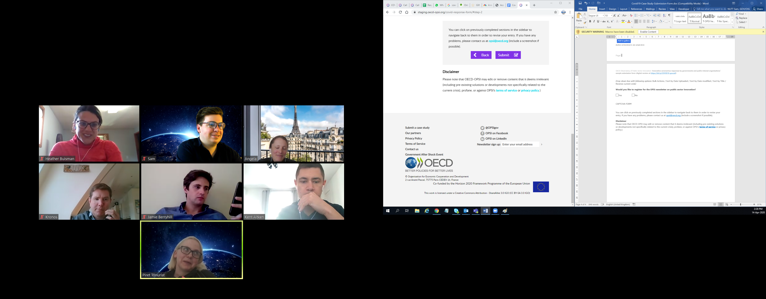
(buttons not functional in .doc sample form)

Disclaimer
Please note that OECD-OPSI may edit or remove content that it deems irrelevant (including pre-existing solutions or developments not specifically related to the current crisis), profane, or against OPSI’s terms of service or privacy policy.)

