Seoul Shinmun October 12, 2018
Page 18 (Special Features)
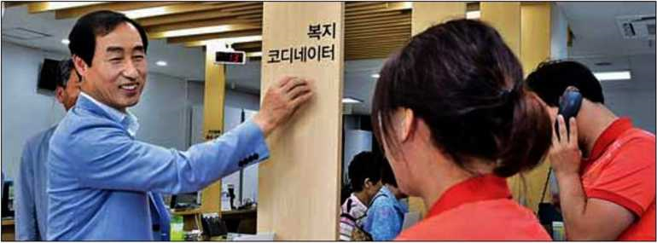
Head of Gu Mun (left) is talking with welfare coordinators responsible for welfare services at a local community center.
Photo courtesy of Seodaemun-gu

Evolution of Sustainable Welfare Services including Welfare Coordination and Moving Community Centers

Seodaemun-gu's Welfare Delivery System Developed for Over Seven Years

The driving force for Seoul's Seodaemun-gu to plan and establish a new welfare delivery system was its steadiness: it pursued its welfare policies under a consistent goal by incrementally raising the aimed level of fulfillment for seven years.
Also, the system started off on the right foot. In 2012, it implemented the "Change Neighborhoods into a Welfare Hub" project on a trial basis at two local community centers. Next year, the project was expanded to all 14 community centers.
Under the system, the services provided by the District Office and community centers were restructured and home-care nurses and welfare coordinators were assigned to each community center, with the organization of community welfare councils. In 2011, the number of welfare personnel amounted to 24% of all the employees of local communities, but it increased to 67% in February 2013.
In 2014, Seodaemun-gu set out to eliminate welfare blind spots by providing at-home welfare services where welfare workers regularly visit the places with welfare needs to uncover vulnerable groups and offer preemptive welfare services.
In 2015, Seodaemun-gu enhanced the efficiency of the welfare delivery system using information technology (IT), creating the nation's first welfare need map and opening the Happy 1004 Call Center and a portal to search customized welfare services.
In 2016, the moving community center service was further expanded, implementing the Seodaemun 1, 2, 3 Happiness Project meaning "linkage among healthcare and welfare agencies and communities." In 2017, Seodaemun-gu's own public-private cooperation system was developed. A total of 13 organizations entered into a consortium agreement with the moving community centers to provide welfare services to those with welfare needs.
"Our final goal is to build a welfare ecosystem through solidarity between health, welfare, villages and public and private sectors, to realize a sustainable welfare community," said Governor of Seodaemun-gu Mun Seok-jin.

By Kang Guk-jin
betulo@seoul.co.kr

