Seoul Shinmun March 29, 2018
Page 12
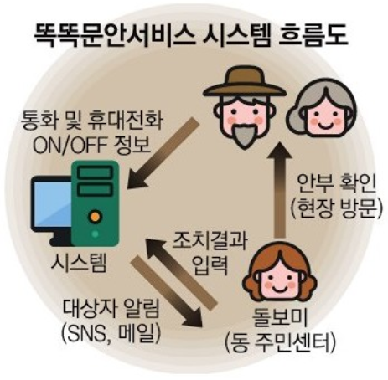  Smart Condition Check System  Calling or device ON/OFF information  Condition check  (Visit)  System  Input the measures taken  Notification to welfare personnel  (social media, e-mail)  Welfare personnel  (Local community center) | 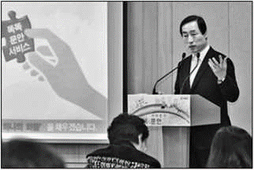
 | Governor of Seodaemun-gu Mun Seok-jin is giving a presentation on the Smart Condition Check service in the briefing room of Seoul City Hall’s Press Hall on March 28. Photo courtesy of Seodaemun-gu

Seodaemun-gu to Prevent Solitary Deaths of Residents Living Alone by Visiting Them When No Mobile Phone Log is Collected

First to Introduce a Condition Check System for the Elderly Using Mobile Phone Logs
Welfare Employees to Call and Visit Those with No Mobile Phone Log for a Certain Period
No Equipment Installation Required and Service Fee Borne by Seodaemun-gu

Seodaemun-gu introduces the nation's first service to prevent solitary deaths by using the mobile phone logs of residents living alone.
Seodaemun-gu, Seoul and SK Telecom announced on March 28 that they launched Smart Condition Check service, a system for checking the condition of residents linked to the status of their mobile phone calling records. The service intends to prevent the increase in solitary deaths due to the growing number of single-person households and the loss of social safety net.
The Smart Condition Check service uses a system to send notifications to the District Office's internal computer network when it fails to collect calling records from residents living alone or when their mobile phones remain turned off for a certain period of time. For example, if the residents who have applied for the service and set the period to three days stop using their mobile phone or keep it off for over three days, a text message and an e-mail asking the employees of local community centers to check their conditions are automatically sent. The employees then contact the residents and if they cannot reach them, they visit them directly.
The service is available to single-person households aged 65 or over and in their 40s to 50s and people in substandard residential conditions such as gosiwon or small single monthly paid rooms. The service is provided on a trial basis from March 29 to April 8 to those who applied for the service and be officially launched on April 9.
The monthly service fee of 1,000 won is borne by Seodaemun-gu. The service requires no installation of additional equipment and can be applied to 2G phones that are widely used by the elderly.
In the case of motion detectors using existing Internet of Things (IoT) technology, the installation for the device costs about 1 million won per household, which limits the range of the beneficiaries of the service.
Seodaemun-gu, SK Telecom, and IT company Lucis started the development of the system in November 2016. Currently, only SK Telecom users can use the service, but it will be expanded within the first half of the year so that users of telecommunication providers such as KT and LG Uplus can benefit from the service.
"Perhaps we cannot prevent all solitary deaths with the service, however, it will complement the existing care service that has been provided by yogurt deliverers who also check the conditions of residents living alone. It is important to tighten the welfare net and prevent anyone from being excluded," said District Governor Mun Seok-jin.
By Yoon Su-gyeong
yoon@seoul.co.kr

